Myocardial ischemia-reperfusion injury alters inflammation-associated
gut microbiota in rat

Cuifang Kuang¹, Lingqing Su¹, Manman Qin¹, Liang Qiu^{1*}, Jun Yu^{1,2,*}
¹Key Laboratory for Pharmacology and Translational Research of Traditional Chinese Medicine of Nanchang, Center for Translational Medicine, Jiangxi University of Traditional Chinese Medicine, Nanchang, Jiangxi 330004, China; ²Center for Metabolic Research Disease and Department of Physiology, Lewis Katz School of Medicine, Temple University, Philadelphia, PA 19140, USA

*Correspondings:
Jun Yu, MD
Department of Physiology and Center for Metabolic Disease Research, Lewis Katz School of Medicine, Temple University, Philadelphia, PA19140, USA.
Tel: 215-707-3286; Fax: 215-707-5737;
Email: jun.yu@temple.edu

Liang Qiu, PhD
Center for Translational Medicine, Jiangxi University of Traditional Chinese Medicine, Nanchang, Jiangxi, 330004, China
Email: liangqiu@jxutcm.edu.cn
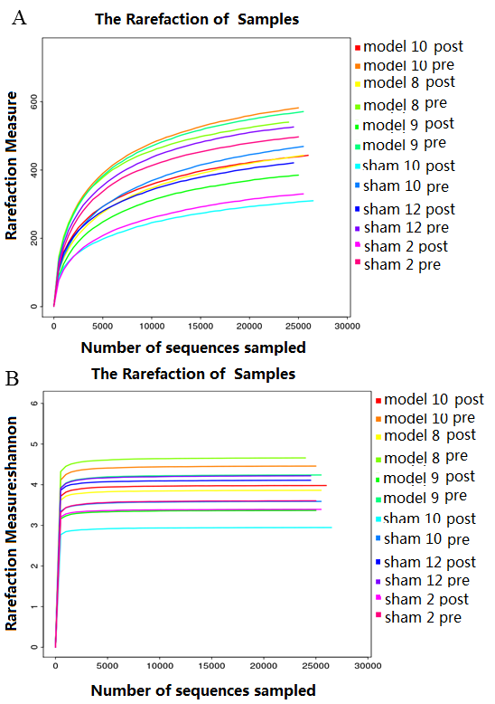
Supplementary Figure 1

Figure S1 Rarefaction curves compares species richness (A. observed OTU number) and overall diversity (B Shannon index) among samples.

Supplementary Figure 2

Figure S2 Venn plot of operational taxonomic unit (OTU) distribution. Each ellispe represents one group of samples. The overlapping regions between the ellipses represent the shared OTUs between two groups. The value for each region represents the number of OTUS.

Supplementary Figure 3

Figure S3 Venn plot of operational taxonomic unit (OTU) distribution. Each ellispe represents one group of samples. The overlapping regions between the ellipses represent the shared OTUs between two groups. The value for each region represents the number of OTUS.

Supplementary Table S1

Table S1 Relative abundance of bacterial phylum among post-I/R, post-sham, pre-sham and pre-I/R
phylum | model10post | model10pre | model8post | model8pre | model9post | model9pre | sham10post | sham10pre | sham12post | sham12pre | sham2post | sham2pre
Bacteroidetes | 40.11 | 53.15 | 57.49 | 43.41 | 64.38 | 57.69 | 27.01 | 70.20 | 47.55 | 52.38 | 60.29 | 69.44
Firmicutes | 29.66 | 41.30 | 20.93 | 51.30 | 26.31 | 35.81 | 20.20 | 23.54 | 26.15 | 43.79 | 19.98 | 24.81
Proteobacteria | 12.74 | 2.68 | 14.42 | 3.70 | 7.37 | 2.03 | 52.03 | 1.65 | 18.352 | 1.68 | 19.18 | 0.81
Spirochaetes | 12.15 | 1.40 | 6.60 | 0.12 | 0.29 | 1.95 | 0.36 | 2.12 | 7.21 | 0.32 | 0.21 | 1.59
Actinobacteria | 4.85 | 0.32 | 0.15 | 0.10 | 0.34 | 0.19 | 0.31 | 0.07 | 0.24 | 0.12 | 0.07 | 0.04
Tenericutes | 0.29 | 0.51 | 0.29 | 0.95 | 1.06 | 1.23 | 0.05 | 0.66 | 0.41 | 0.87 | 0.17 | 2.17
Deferribacteres | 0.14 | 0.021 | 0.004 | 0.11 | 0 | 0.08 | 0.004 | 0.01 | 0.02 | 0.008 | 0.02 | 0.02
Unclassified | 0.06 | 0.15 | 0.07 | 0.18 | 0.035 | 0.33 | 0.01 | 0.14 | 0.05 | 0.33 | 0.04 | 0.29
Cyanobacteria | 0 | 0.48 | 0.032 | 0.13 | 0.18 | 0.68 | 0.01 | 1.60 | 0.02 | 0.50 | 0.04 | 0.81
Elusimicrobia | 0 | 0.004 | 0.02 | 0.004 | 0.01 | 0 | 0 | 0.004 | 0 | 0 | 0 | 0.02
Lentisphaerae | 0 | 0 | 0 | 0 | 0.008 | 0 | 0 | 0 | 0 | 0 | 0 | 0

